**“Experiment – 8”**

Name: **SUMIT KUMAR** UID: **20BCS8226**

Branch: **BE-CSE** Section/Group: **MM 808 A**

Semester: **5th** Date of Submission: **10/11/22**

Subject Name: **Machine Learning Lab** Subject Code: **20CSP-317**

**1. Aim/Overview of the practical:**

Implement K-means clustering algorithm (cluster some sample data set into disjoint clusters using K-means).

**2. Task to be done/ Which logistics used:**

Implement K-means clustering algorithm (cluster some sample data set into disjoint clusters using K-means).

**3. Steps for experiment/practical/Code:**

**Implements K-Mean Clustering on Any Dataset.**

"""

import matplotlib.pyplot as plt

from sklearn.cluster import KMeans

"""# **This is the Specific Example for the K-Mean Clustring**"""

x = [4, 5, 10, 4, 3, 11, 14 , 6, 10, 12]

y = [21, 19, 24, 17, 16, 25, 24, 22, 21, 21]

data = list(zip(x, y))

print(data)

plt.scatter(x, y)

plt.show()

inertias = []

for i in range(1,11):

    kmeans = KMeans(n_clusters=i)

    kmeans.fit(data)

    inertias.append(kmeans.inertia_)

plt.plot(range(1,11), inertias, marker='o')

plt.title('Elbow method')

plt.xlabel('Number of clusters')

plt.ylabel('Inertia')

plt.show()

kmeans = KMeans(n_clusters=2)

kmeans.fit(data)

plt.scatter(x, y, c=kmeans.labels_)

plt.show()

**4. Result/Output/Writing Summary:**

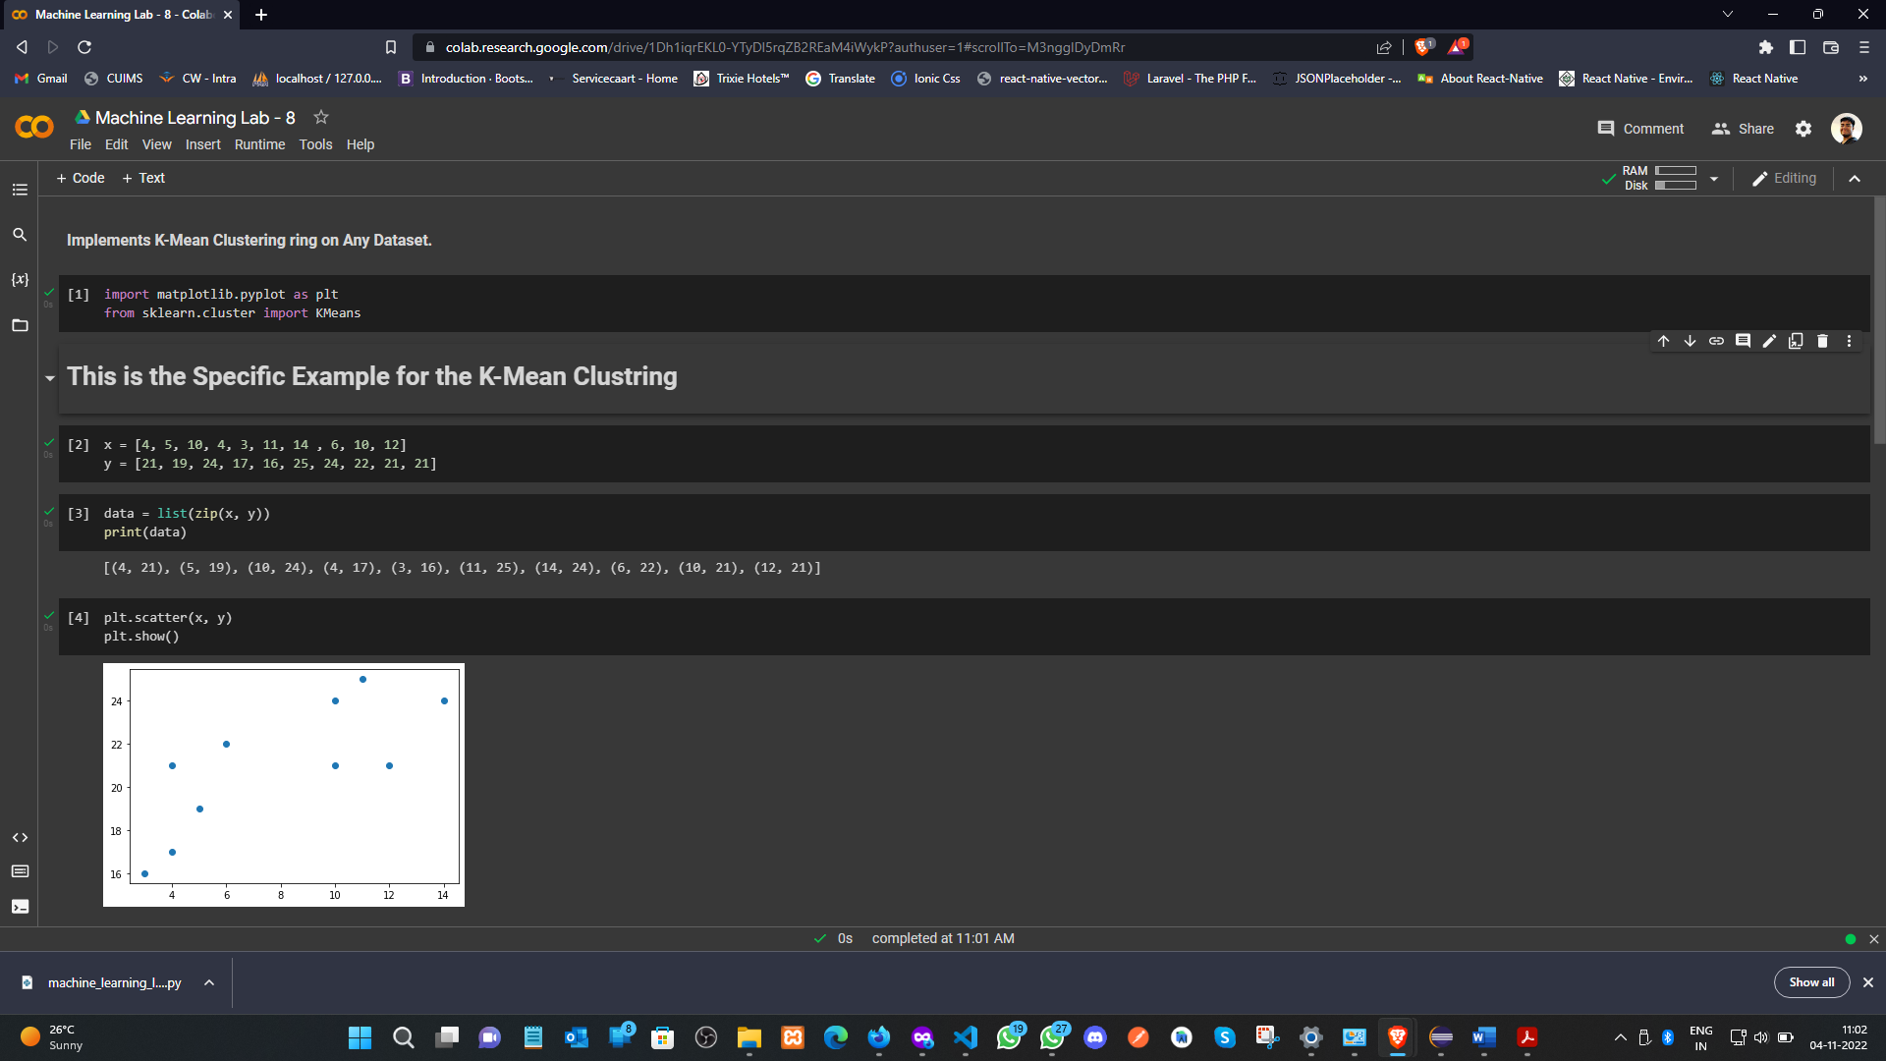

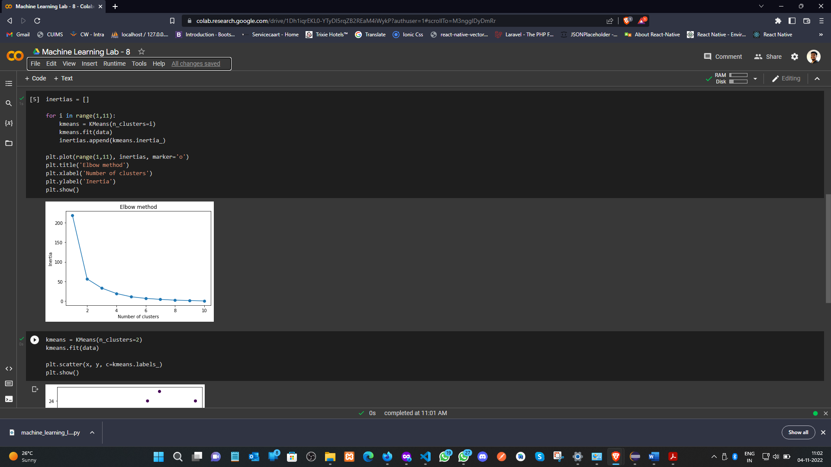 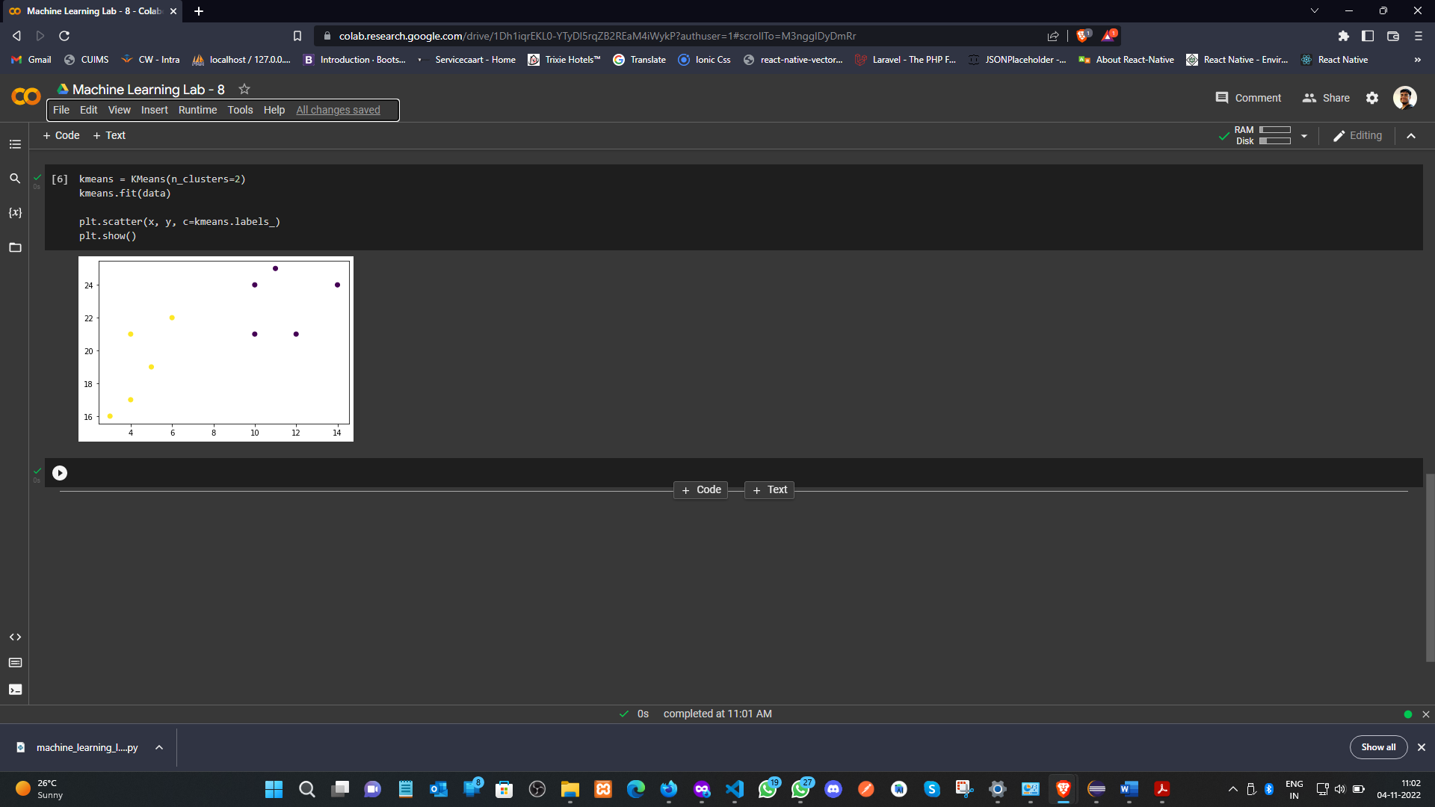

**Learning outcomes (What I have learnt):**

1. Understood the concept of K-Mean.
2. Learnt how to zip the two-array data in a single list.
3. Learnt the Inertia calculation.
4. Plot the graph for Inertia and Number of clusters.

**Evaluation Grid (To be created as per the SOP and Assessment guidelines by the faculty):**

|  |  |  |  |
| --- | --- | --- | --- |
| Sr. No. | Parameters | Marks Obtained | Maximum Marks |
| 1. |  |  |  |
| 2. |  |  |  |
| 3. |  |  |  |
|  |  |  |  |